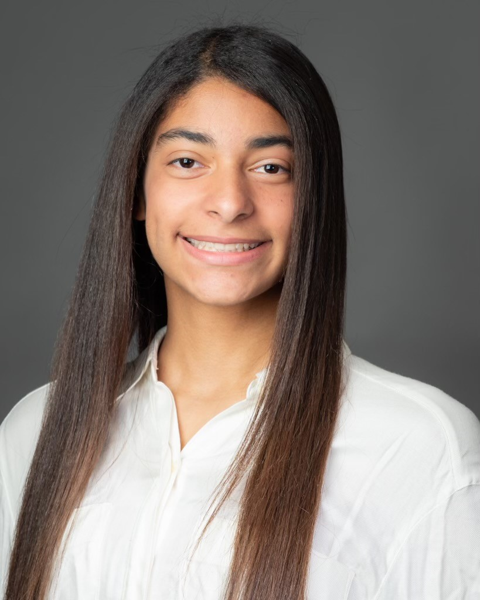
Sofiaenid Rodney-Hernández to Attend FutureVets’ Program in Coronado, Costa Rica
Dallas, Texas – Sofiaenid Rodney-Hernández, a 12 grade at Hillcrest High School will attend a summer program in Coronado, Costa Rica from July 30 – August 13, 2022.
FutureVets is an exclusive, once-in-a-lifetime opportunity for qualified high school students to experience real veterinary medicine. The purpose of this internship is to honor, inspire, motivate, and direct the top students in the country who aspire to have careers in the veterinary field, to stay true to their dream and, after the program, to provide a path, plan, and resources to help them reach their goal.
“I want to learn how to treat and take care of the animals. This opportunity is a dream come true, can’t wait for rotations!” says Sofiaenid Rodney-Hernández.
During the two-week program, Sofiaenid Rodney-Hernández will join students from across the United States and spend time observing surgeries taking place in the operating room, with the surgeon explaining the procedure as it’s being performed.
Sofiaenid Rodney-Hernández will be in the gross anatomy lab with an anatomy professor, learning about the anatomy and proper dissection of cadavers. They will practice dissection techniques and view necropsies.
And Sofiaenid Rodney-Hernández will also shadow veterinarians as they treat, diagnose, and rehabilitate small and large animals (oftentimes in their natural habit), participate in rotations, clinical lab research, and nutrition.
FutureVets is a program of The National Leadership Academies, which was founded on the belief that strong emotional intelligence is the cornerstone of student success and is committed to supporting students in their development. The National Leadership Academies also recognizes that prospective talent must be identified at the earliest possible age and help must be given to these students to acquire the necessary experience and skills to take them to the doorstep of vital careers as leaders and in the fields of medicine and the sciences.
For more information, please visit www.thenationalleadershipacademies.com or call (888) 986-6563.
